A

**PROJECT REPORT**

**ON**

***Ele-Desk***

**Submitted By**

***Jimit S. Dagli (206090307002)***

***Vishal R. Parmar (206090307031)***

***Sumeet K. Kapadia (206090307059)***

***Tirth M. Doshi (206090307063)***



**To**

**COMPUTER ENGINEERING DEPARTMENT**

**C U SHAH GOVT. POLYTECHNIC – SURENDRANAGAR**

**GUJARAT TECHNOLOGICAL UNIVERSITY – AHMEDABAD**

**MAY-2023**

|  |  |  |
| --- | --- | --- |
|  | **C U SHAH (GOVT) POLYTECHNIC SURENDRANAGAR**  **COMPUTER ENGINEERING DEPARTMENT** |  |

### CERTIFICATE FOR COMPLETION OF PROJECT-II

This certificate is proudly awarded to **Jimit .S. Dagli** Enrollment No.

**206090307002** of Diploma **Semester VI** (Computer Engineering). He has

Completed his project work titled **Ele-Desk** satisfactorily in partial fulfillment of

Requirement of Diploma in Computer Engineering, Gujarat Technology University, Ahmadabad, in the year **2022-23**.

Date of Submission: 22/05/2023

Sign of Internal Guide:

Name of Internal Guide: **Mr. B.D. Limbasiya**

|  |  |
| --- | --- |
| Sign of Project Coordinator | HOD  Computer Engineering Department |

|  |  |  |
| --- | --- | --- |
|  | **C U SHAH (GOVT) POLYTECHNIC SURENDRANAGAR**  **COMPUTER ENGINEERING DEPARTMENT** |  |

### CERTIFICATE FOR COMPLETION OF PROJECT-II

This certificate is proudly awarded to **Vishal .R. Parmar** Enrollment No.

**206090307031** of Diploma **Semester VI** (Computer Engineering). He has

Completed his project work titled **Ele-desk** satisfactorily in partial fulfillment of

Requirement of Diploma in Computer Engineering, Gujarat Technology University, Ahmadabad, in the year **2022-23**.

Date of Submission: 22/05/2023

Sign of Internal Guide:

Name of Internal Guide: **Mr. B.D. Limbasiya**

|  |  |
| --- | --- |
| Sign of Project Coordinator | HOD  Computer Engineering Department |

|  |  |  |
| --- | --- | --- |
|  | **C U SHAH (GOVT) POLYTECHNIC SURENDRANAGAR**  **COMPUTER ENGINEERING DEPARTMENT** |  |

### CERTIFICATE FOR COMPLETION OF PROJECT-II

This certificate is proudly awarded to **Sumeet.K.Kapadia** Enrollment No.

**206090307059** of Diploma **Semester VI** (Computer Engineering). He has

Completed his project work titled **Ele-Desk** satisfactorily in partial fulfillment of

Requirement of Diploma in Computer Engineering, Gujarat Technology University, Ahmadabad, in the year **2022-23**.

Date of Submission: 22/05/2023

Sign of Internal Guide:

Name of Internal Guide: **Mr. B.D. Limbasiya**

|  |  |
| --- | --- |
| Sign of Project Coordinator | HOD  Computer Engineering Department |

|  |  |  |
| --- | --- | --- |
|  | **C U SHAH (GOVT) POLYTECHNIC SURENDRANAGAR**  **COMPUTER ENGINEERING DEPARTMENT** |  |

### CERTIFICATE FOR COMPLETION OF PROJECT-II

This certificate is proudly awarded to **Tirth .M. Doshi** Enrollment No.

**206090307063** of Diploma **Semester VI** (Computer Engineering). He has

Completed his project work titled **Ele-Desk** satisfactorily in partial fulfillment of

Requirement of Diploma in Computer Engineering, Gujarat Technology University, Ahmadabad, in the year **2022-23**.

Date of Submission: 22/05/2023

Sign of Internal Guide:

Name of Internal Guide: **Mr. B.D. Limbasiya**

|  |  |
| --- | --- |
| Sign of Project Coordinator | HOD  Computer Engineering Department |

### ACKNOWLEDGEMENT

As human being, it is quite apparent that we have limited knowledge, but we have always tried to make the most of what we know, I would there for, like to begin by thanking almighty, who is the ocean of knowledge for helping me to undertake many in such a big enterprise as we have done.

I would like to give sincere thanks to **Prof. M. B. Kalariya,** Head of Computer Department who gave me opportunity to get Industrial Training in our last year.

I also want to sincere thanks **Mr. B. D. Limbasiya**, who gave me valuable guidance during the project.

With sincere regards,

Jimit S Dagli (206090307002)

Vishal R Parmar (206090307031)

Sumeet K Kapadia (206090307059)

Tirth M Doshi (206090307063)

### ABSTRACT

The title is “Ele-Desk”. “Ele-Desk” project is a supply or sharing of resources between a Supplier, a Dealer and a Wholesaler. There are a lot of products manufactured by the company “*Zell Electronics*” like laptop, TV’s and mobiles.

The Supplier will be the Supplier of the products. The Dealers will place the orders to the Supplier, and Wholesalers will place the orders to Dealers.

Once they place the order, they will get the discount according to their purchases.

“Ele-Desk” is for resolving the problem of offline purchases and with this, we can make online order which helps in saving time and making additional charges like traveling to the Supplier.

### NOTATIONS

1. Notations for Use Case: -

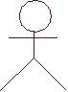Actor

Use Case

1. Notations for Activity Diagram: -

Activity

Branch/Division

1. Notations for E-R Diagram: -

Entity

Condition

Attribute

Relation

1. Notations for Data Flow Diagram: -

Entity

Process

Data store Data Flow

**INDEX**

|  |  |  |  |  |
| --- | --- | --- | --- | --- |
| **Chapter** | **Topic No** | **Titles** | | **Page No.** |
| **1.** | **Introduction** | | | **1** |
|  | 1.1 | Project profile | | 2 |
|  | 1.2 | Introduction | | 3 |
|  | 1.3 | Scope | | 3 |
|  | 1.4 | Objective | | 3 |
|  | 1.5 | Motivation | | 4 |
|  | 1.6 | Challenges to our Project | | 4 |
| **2.** | **Project Management** | | | **5** |
|  | 2.1 | Project Planning and scheduling | | 6 |
|  |  | 2.1.1 | Project Development Approach (SDLC Process  Model) | 6 |
|  |  | 2.1.2 | Project Plan, Milestone and deliverable | 7 |
|  |  | 2.1.3 | Schedule Representation | 8 |
|  | 2.2 | Risk Management | | 9 |
|  |  | 2.2.1 | Risk Identification | 9 |
|  |  | 2.2.2 | Risk Analysis | 9 |
|  |  | 2.2.3 | Risk Planning | 10 |
| **3** | **System Requirements Study** | | | **11** |
|  | 3.1 | User Characteristics | | 12 |
|  | 3.2 | Hardware and Software Requirements | | 12 |
|  | 3.3 | Constraints | | 12 |
| **4** | **System Analysis** | | | **13** |
|  | 4.1 | Study of Current System (Background Study) | | 14 |
|  | 4.2 | Problem and Weaknesses of Current System | | 14 |
|  | 4.3 | Requirements of New System | | 15 |

|  |  |  |  |  |
| --- | --- | --- | --- | --- |
|  | 4.4 | Feasibility Study | | 15 |
|  | 4.5 | Functional and Non-Functional Requirements | | 16 |
|  | 4.6 | Functions Of System | | 18 |
|  |  | 4.6.1 | Use Cases Diagram | 18 |
|  | 4.7 | Data Modelling | | 21 |
|  |  | 4.7.1 | Class Diagram | 21 |
|  |  | 4.7.2 | System Activity (Activity Diagram) | 22 |
|  |  | 4.7.3 | Data Dictionary | 25 |
|  | 4.8 | Functional and Behavioral Modelling | | 27 |
|  |  | 4.8.1 | Context Diagram (DFD Level 0) | 27 |
|  |  | 4.8.2 | Data Flow Diagram (Level 1) | 28 |
|  |  | 4.8.3 | Process specification | 32 |
|  | 4.9 | Main module of new system. | | 32 |
|  | 4.10 | Selection of hardware and software and justification | | 32 |
| **5** | **System Design** | | | **34** |
|  | 5.1 | Database design/ Data structure design | | 35 |
|  |  | 5.1.1 | Tables and Relationship | 35 |
|  | 5.2 | Input /output and interface | | 36 |
|  |  | 5.2.1 | Sample of forms, reports and interface | 36 |
|  |  | 5.2.2 | Access control and security | 40 |
| **6** | **Implementation And Planning** | | | **41** |
|  | 6.1 | Implementation Environment | | 42 |
|  | 6.2 | Program/Module Specification | | 43 |
|  | 6.3 | Coding Standard | | 44 |
|  | 6.4 | Sample Coding | | 44 |
| **7** | **Testing** | | | **47** |
|  | 7.1 | Testing Plans | | 48 |
|  | 7.2 | Testing Strategy | | 49 |
|  | 7.3 | Testing Methods | | 50 |
|  | 7.4 | Test Cases | | 52 |
| **8** | **Screenshot And User Manual** | | | **55** |
| **9** | **Limitations And Future Enhancement** | | | **66** |
|  | Limitations | | | 67 |

|  |  |  |
| --- | --- | --- |
|  | Future Enhancement | 67 |
| **10** | **Conclusion And References** | **68** |
|  | Conclusion | 69 |
|  | References | 69 |

## CHAPTER-1



INTRODUCTION

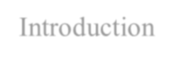

* Project Profile
* Introduction
* Scope
* Objective
* Motivation
* Challenges to our project

### PROJECT PROFILE

|  |  |  |
| --- | --- | --- |
| **Group ID** | **:** | **G-3** |
| **Project Title** | **:** | **ELE-DESK** |
| **Team Detail** | : | Jimit. S. Dagli (*206090307002*)  Vishal. R. Parmar (*206090307031*)  Sumeet. K. Kapadia (*206090307059*)  Tirth. M. Doshi (*206090307063*) |
| **Team Leader** | : | Tirth. M. Doshi (206090307063) |
| **Type of Project** | : | UDP |
| **External Guide (If Any)** | : | -------- |
| **Internal Guide** | : | Mr. B. D. Limbasiya |
| **Project Category** | : | Web Application |
| **Front End** | : | HTML, CSS, Java Script |
| **Back End** | : | PHP |
| **Database Tool** | : | My SQL |
| **Modules** | : | 1. Admin Module 2. Dealer Module 3. Wholesaler Module |

* 1. **INTRODUCTION**

“Ele-Desk” contains three main modules. They are: --

* Admin Module: ---Admin can create the accounts of dealers. He can manage the stock, discount of products. He can receive orders from dealers and dispatch the products to them.
  + - Dealer Module: ---Dealer can create the accounts of wholesalers. He can view the products that admin is selling. He can manage the stock of products. He can send orders to admin and receive orders from wholesalers. He can dispatch the products to wholesalers.
    - Wholesaler Module: --- Wholesalers can manage the stock of their products, view the products that dealer is selling and can send orders to dealers.

### SCOPE

* + - Using our project the Dealers and Wholesalers are able to easily place the order to the Supplier.
    - This will save a lot of time and money of Dealers and Wholesalers*.*

### OBJECTIVES

* + - Save time of Dealers and Wholesalers.
    - Efficiency.
    - Preventing the extra cost of traveling of Dealers and Wholesalers.

### MOTIVATION:

* + - Motivation for this project is that the Dealers and Wholesalers face a trouble in offline order.
    - The outcome for this project is that we are able to place the orders online.
    - The Supplier, Dealers and Wholesalers all of them will be benefited.

### Technology and Literature Review

* + - Technology:-
      * Front End: - HTML, CSS, Java Script
      * BACK END: -- PHP
      * DATABASE TOOL: -- MY SQL

### Literature Review:-

We got some ideas from general business problems like to purchase the stock of products by traveling long distance to purchase their products.

We also got the idea from the website called delivery.com. It is somewhat similar to this project.

Reference Link: --- <http://www.delivery.com/setup-business/blogs/>

### CHALLENGES OF YOUR PROJECT

* + - To manage the orders of dealers and wholesalers.
    - To manage the stock of products.
    - To manage warranty related queries.
    - Data management about dealers and wholesalers.

**Ele-Desk**

## CHAPTER-2



PROJECT PLANNING AND PLANNING SCHEDULING RISK MANAGEMENT

### PROJECT PLANNING AND SCHEDULING

* + 1. Project Development Approach (SDLC Process Model) and Justification.

**Software Development Cycle:**

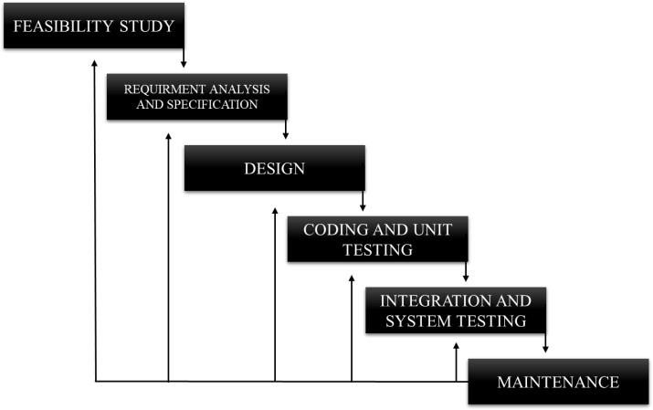

**(Iterative Waterfall Model)**

* + - * We chose **“Iterative Waterfall Model”** for this project.
      * Reasons: --
        + It is very simple to understand and use.
        + Testing during smaller iteration is easy.
        + Less time is spent on documenting and more time is given for designing.
        + Risks are identified and resolved easily.
        + It is highly cost-effective to change the plan or requirements in the model.
        + Unlike Waterfall Model, Iterative Waterfall Model allows to make changes by going to the previous phase.
    1. **Project Scheduling**

|  |  |  |  |  |
| --- | --- | --- | --- | --- |
| Project Title: | | | | |
| Sr No | Milestone | Start Date | End Date  /Milestone Date | Duration (Days) |
| 1 | Requirement Gathering | 18-07-2022 | 31-07-2022 | 14 |
| 2 | Analysis and Module Specification | 01-08-2022 | 20-08-2022 | 20 |
| 3 | Planning and Risk Identification | 21-08-2022 | 25-08-2022 | 5 |
| 4 | UML Diagram Designing | 26-08-2022 | 14-10-2022 | 50 |
| 5 | Database Design, Sample Page Design | 15-10-2022 | 08-11-2022 | 25 |
| 6 | Project-1 Documentation | 09-11-2022 | 28-11-2022 | 20 |
| 7 | GUI Design | 01-01-2023 | 31-01-2023 | 31 |
| 8 | Coding and Implementation | 01-02-2023 | 12-03-2023 | 40 |
| 9 | Deployment | 13-03-2023 | 01-04-2023 | 20 |
| 10 | Testing | 02-04-2023 | 16-04-2023 | 15 |
| 11 | Documentation | 17-04-2023 | 01-05-2023 | 15 |
| Total Days | | | | 255 |

* + 1. **Schedule Representation**

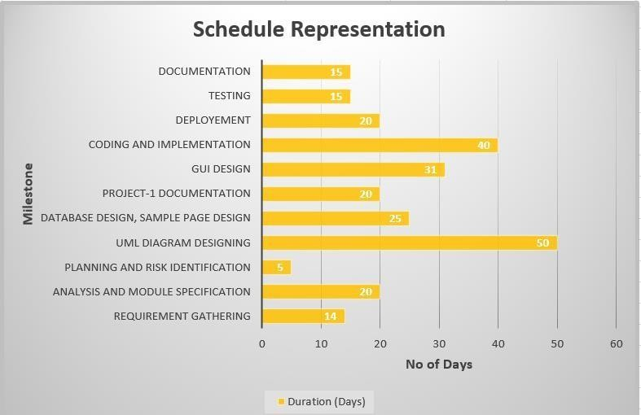

* + 1. **Roles and Responsibilities:**

|  |  |  |
| --- | --- | --- |
| **Sr No** | **Responsibility** | **Team Member Name** |
| 1 | Requirement Gathering | Tirth Doshi |
| 2 | Analysis and Module Specification | Vishal,Tirth |
| 3 | Planning and Risk Identification | Tirth Doshi |
| 4 | UML Diagram Designing | Vishal Parmar |
| 5 | Database Design, Sample Page Design | Jimit, Sumeet |
| 6 | Project-1 Documentation | Tirth, Jimit, Sumeet, Vishal |
| 7 | GUI Design | Jimit |
| 8 | Coding and Implementation | Jimit, Sumeet |
| 9 | Deployment | Sumeet |
| 10 | Testing | Vishal Parmar |
| 11 | Documentation | Tirth, Jimit, Sumeet, Vishal |

### Risk Management

* Project Risk Management involves conducting risk management planning, engaging in risk identification, completing risk analysis, creating a risk response action plan, and monitoring and controlling risk on a project. Project Risk Management is a continuous process to been Gage din throughout the entire project. A key point to remember is that risk is not always bad. There are opportunities and the rare threats. The opportunities are the good risks. The threats are the bad risks.
  + 1. Risk Identification
* Risk Identification is systematic attempt to specify threats to the project plan. By identifying the known and predictable risks, the project manager takes a first step towards avoiding them when possible and controlling them when necessary. One method of identifying risk is to create a risk item checklist. The checklist can be used for risk identification and focuses on some subset of known and predictable risks in the following subcategories.

Risk in our system are:

* + - * Technical Risk: - it occurs when system fail’s in which project is stored.
      * Schedule risk:- project should be planned very carefully otherwise it Can’t be completed.
      * Performance risk: - it occurs when project doesn’t work properly (as per requirement of client).
      * Support risk: - if new requirement needed by user.
    1. Risk Analysis
* Regardless of the prevention techniques employed, possible threats that could arise inside or outside the organization need to be assessed. Although the exact nature of potential disasters or their resulting consequences are difficult to determine, it is beneficial to perform a comprehensive risk assessment of all threats that can realistically occur to the organization.

Types of Risks: -

* + - * Performance Risk–The degree of uncertainty that the product will meet its requirements and be fit for its intended use. as we are trainees, the performance risk is there in our project.
      * Support Risk –The degree of uncertainty that the resultant software will be easy to correct, adapt, and enhance. Client of this project is in different premises.
      * Project Risks–Threaten the project plan. If project risk become real, it is likely that project schedule will slip and that costs will increase. The budget of this project was decided before starting the project and it is enough to complete it. All the works are divided between team members. Required all the resources are available.
      * Technical Risks–Threaten the quality and timeliness of the s/w to be produced. If technical risk becomes real, implementation may become difficult or impossible. Technology is already decided for this project.
      * Business Risks–Threaten the viability of the s/w to be built. This is live project so business risk is there. Known Risks– are those that can be uncovered after careful evaluation of the project plan.
    1. Risk Planning: -
       - **Risk management planning is the process of deciding how to approach and plan the risk management activities for a project.**

|  |  |
| --- | --- |
| Risk | Strategy |
| Technical Risk | We must have backup. |
| Schedule risk | We must follow our project schedule. |
| Performance risk | Project should work according to client  requirement |
| Support risk | We must provide all kind of support to user. EG:-Technical support. |

## CHAPTER-3



User Characteristics

Hardware and software requirement Constraints

* 1. User Characteristics:-
* Analyzing user characteristics is an important aspect of any project. It allows us to clearly define and focus on who the end users are for the project. Also, it allows checking the progress of the project to ensure that we are still developing the system for the end users. The user must have following characteristics:
  + - User must have basic knowledge of Computers.
    - User must know how to loin into our website.
    - He should know what to order.
    - He should know his email id and password.

#### Hardware and Software requirement:-

* + - **Hardware**: -
      * Pentium-pro processor or later.
      * RAM 2GB or more.
      * HDD 100GB.
    - **Software**: -
      * Windows 7(32-bit/64-bit) or above.
      * Browser.
      * Vs code.

### Constraints:-

* + - Payment module not available.
    - Not for normal users.
    - Dealer cannot create its account by himself, admin has to create account for Dealer. Wholesaler cannot create its account by himself, dealer has to create account for wholesaler.

# CHAPTER*-*4

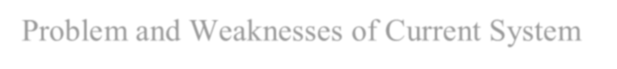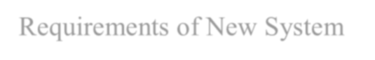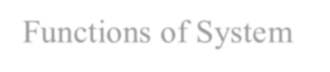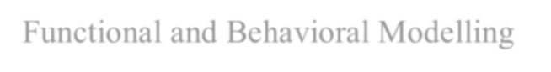

* Study of Current System (Background Study)
* Problem and Weaknesses of Current System
* Requirements of New System
* Feasibility Study
* Functional and Non-Functional Requirements
* Functions of System
* Data Modeling
* Functional and Behavioral Modeling
* Main module of new system.
* Selection of hardware and software and justification

##### SYSTEM ANAYLYSIS

* 1. **Study of Current System (Background Study)**
* We have studied a website a website: - delivery.com
* Delhi very.com is committed to safeguarding the confidentiality, integrity and availability of all physical and electronic information assets of the organization. They ensure that the regulatory, operational and contractual requirements are fulfilled.
* According to the Red Seer Report, Delhi very.com is the largest and fastest growing fully- integrated player in India by revenue in Fiscal 2021. We aim to build the operating system for commerce, through a combination of world-class infrastructure, logistics operations of the highest quality and cutting-edge engineering and technology capabilities.

##### Problem and Weaknesses of Current System

* What are the disadvantages of Ele-Desk?
* There are troubles user may have to face with our website. Here are some of the common disadvantages Ele-Desk users often report.
* Payment module not available: -

In absence of payment module our users may face after giving order.

* Managing Dealers: -

Good relationships with your dealers are key to managing our system effectively. It’s up to us to know how many dealers are needed, how to handle them, and how to receive orders.

* Costing: -

Due to the constant change in the market, coming from a variety of sources such as consumer demands, political agendas and global sourcing, would cause major issues.

* Fast-Changing Markets: -

With technological advancements changing our markets every day, it is quite difficult to stay in pace and adapt to the variety of products in the market.

* Quality control and defects: -

Quality issues is also challenging to manage.

##### Requirement of New System

* To solve the above problem, we need computerized system that manages all the aspects which is possible to be made its computerized. Admin can manage whole the website easily. This website provides all the information which is stored in their database. Our web application solve all the problems of the Dealers and Wholesalers. Our system will help Dealers and Wholesalers make contactless orders. This will save a lot of time and money of them. Our system will help in bringing Dealers and Wholesalers into making their business online.

##### Feasibility study

* A feasibility study is a detailed analysis that considers all of the critical aspects of a proposed project in order to determine the likelihood of it succeeding. Feasibility study can help you determine whether or not you should proceed with your project. It is essential to evaluate cost and benefit. It is essential to evaluate cost and benefit of the proposed system. Four types of feasibility study are taken into consideration:-
* **Technical feasibility:-**
* In this we check whether we have technical resources like hardware and software to develop the project, In our system we used HTML, CSS and Java Script for front end and PHP for back end and we used MY SQL for establishing database connection. So we can say our system is technically feasible.
* **Economic Feasibility:-**
* In this a detail analysis is carried out to know the profit and cost of the project, If the profit is more than the cost of the project then we can say it is economically feasible, For our system we have used PHP as back end , MY SQL for database and java script as front end as all the software are free we can say our system is economically feasible.
* Schedule Feasibility:-
* In this we check whether we have enough time to complete the project on time or not ,As per for our system we have estimated that we have enough time to complete the project on time, So we can say our system is schedule feasible.
* Operational Feasibility:-
* The main purpose of this is to check that whether the project satisfy the customer requirement or not and will it be functional after development, As per our system, It will be fully functional after development, So we can say our system is operationally feasible.

##### Functional and Non Functional Requirements

* + 1. Functional Requirements: -
       - Supplier: --
         1. Login
         2. Dealer Accounts Create
         3. Stock of Product
         4. Discount of Products
         5. Receive Order
         6. Dispatch of Product.
       - Dealer: --
         1. Login
         2. Wholesaler Account Create
         3. Stock of Products
         4. View Product
         5. Send Order to Supplier
         6. Receive Order of Wholesaler
         7. Dispatch of Products.
       - Wholesaler: --
         1. Login
         2. Stock of Products
         3. View Products
         4. Send Order to Dealer.
    2. Non-Functional Requirements: -
       - Portability - as we have used php as it is platform independent so or website is portable
       - Manageability - The site will stay up and running while the administrator edits the code for users.
       - Flexibility – we will be able to make changes in future to our website if any new requirement is added
       - [Security](https://en.wikipedia.org/wiki/Computer_security) – we will make sure that our users’ personnel data is secure.

##### Functions of System

* + 1. use case diagram: -
       - Supplier: --

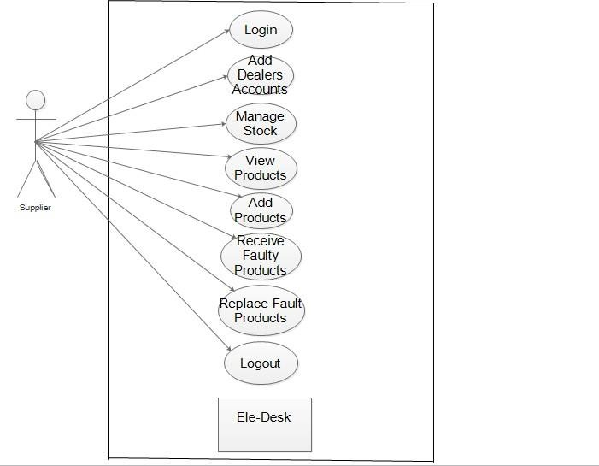

* + - * Dealer**: --**

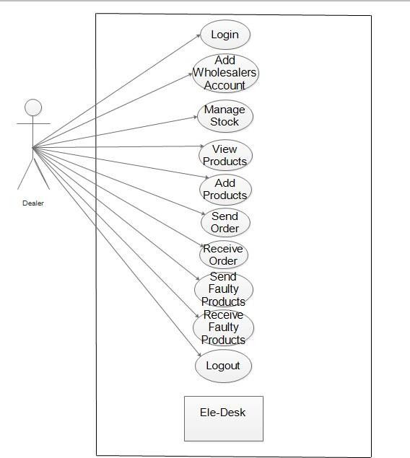

* + - * Wholesalers: --

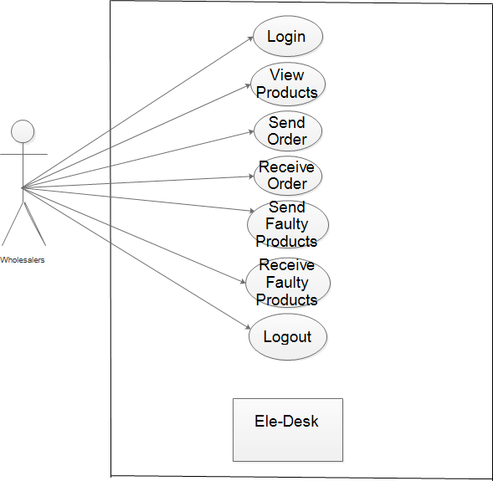

##### Data Modelling

* + 1. Class diagram: -

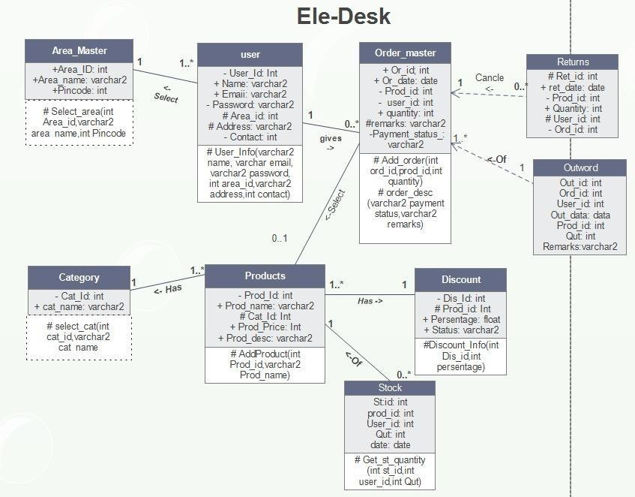

* + 1. **Activity diagram: -**
       - Supplier**: --**

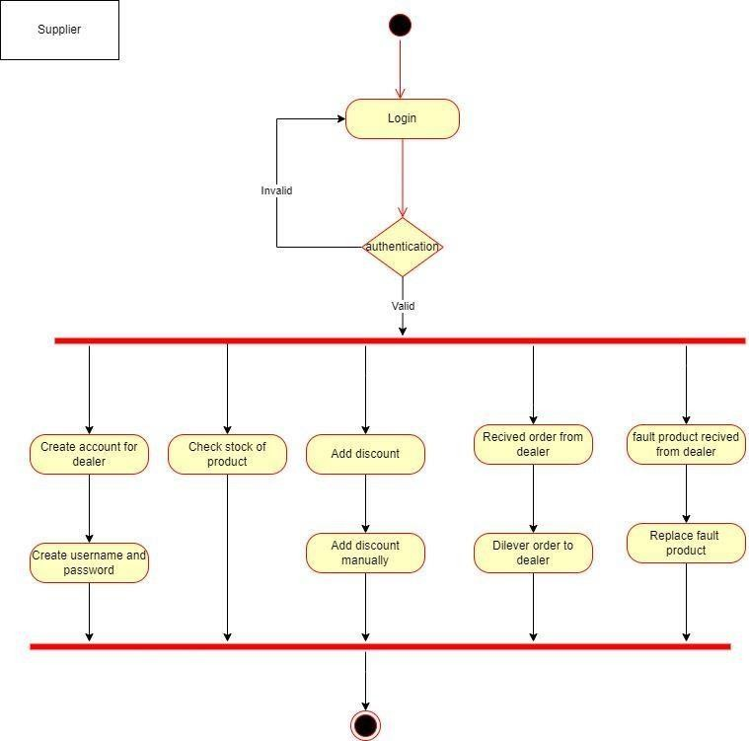

* + - * Dealer**: --**

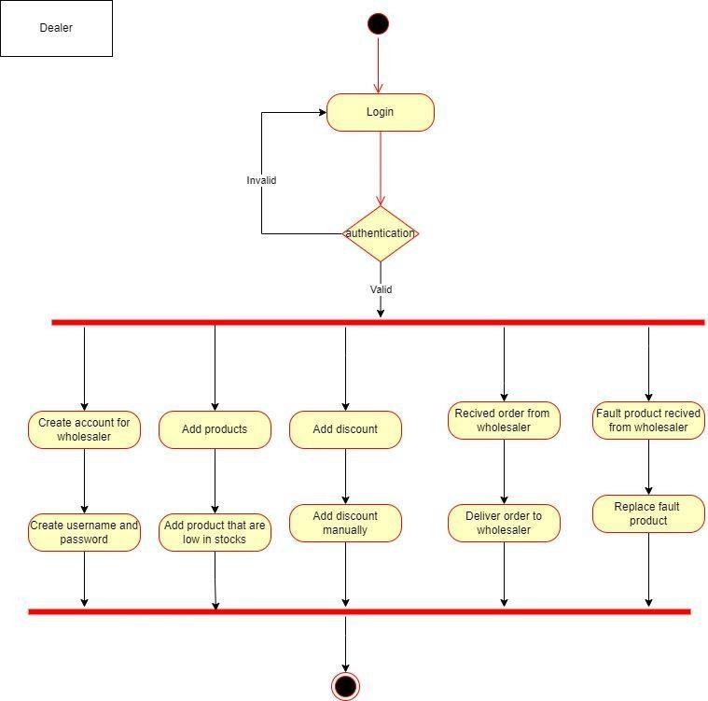

* + - * Wholesaler**: --**

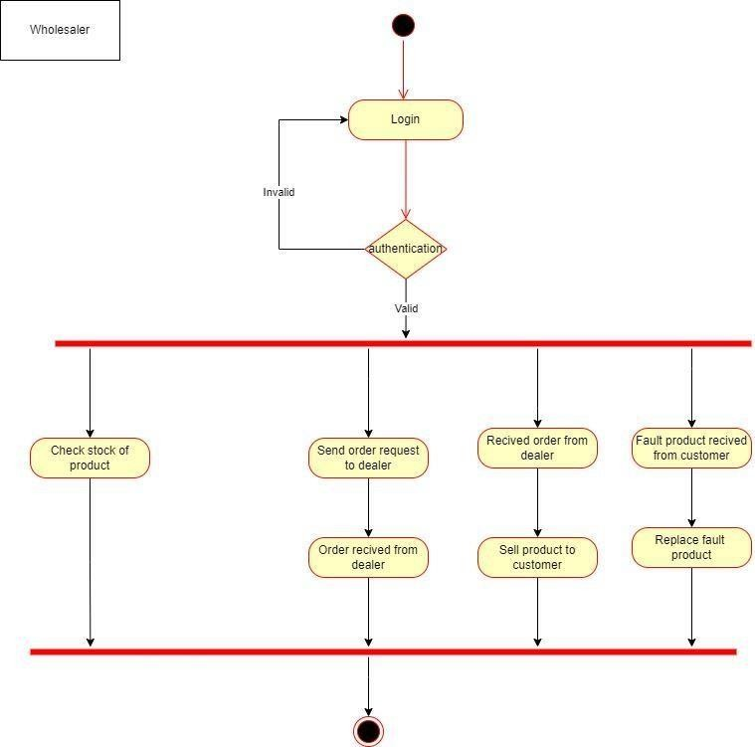

* + 1. **Data dictionary: -**

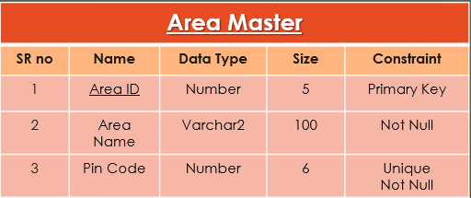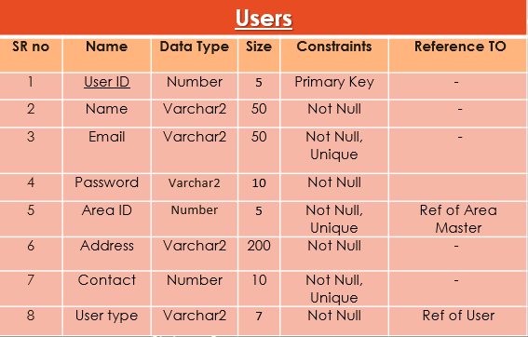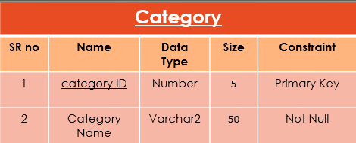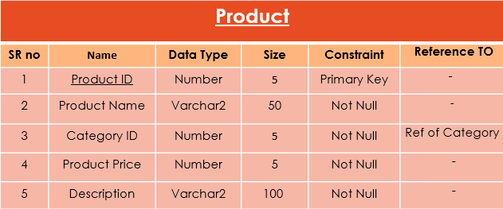

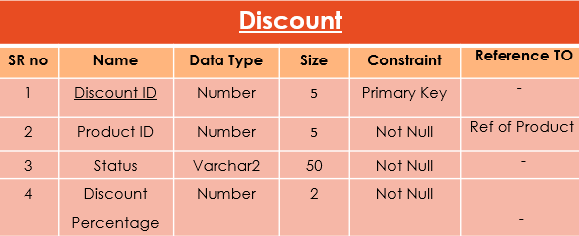

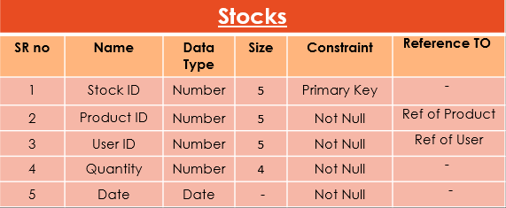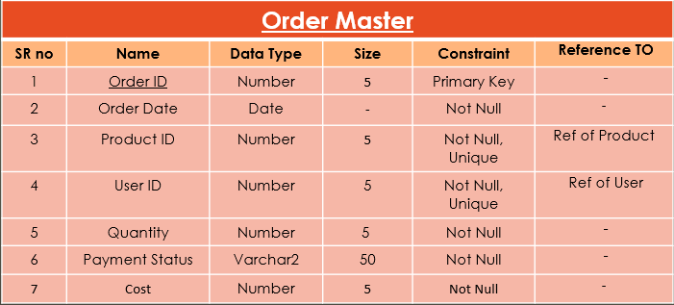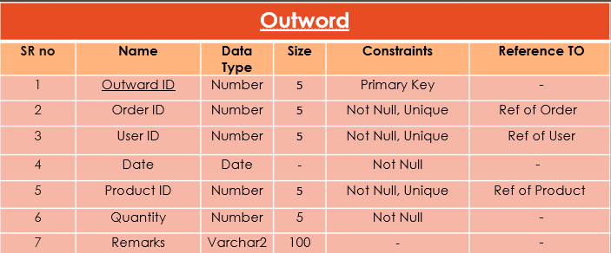

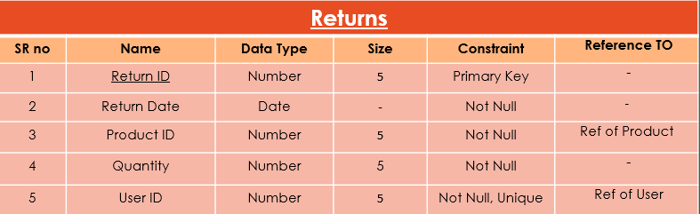

##### Functional and Behavioral Modelling

* + 1. **Context Diagram (DFD Level 0): -**

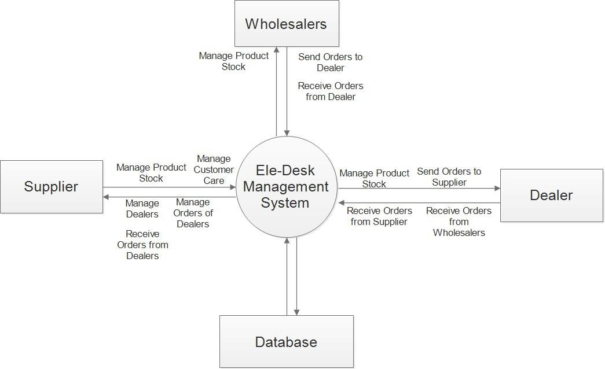

* + 1. **DFD Level 1: -**

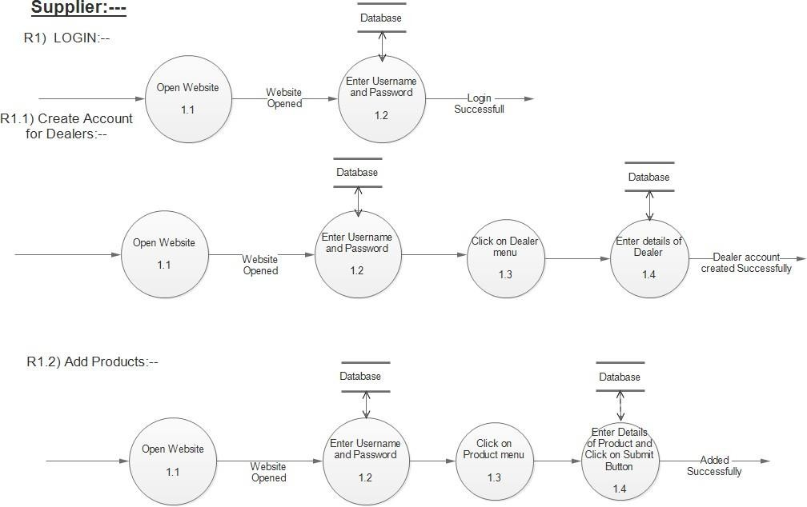

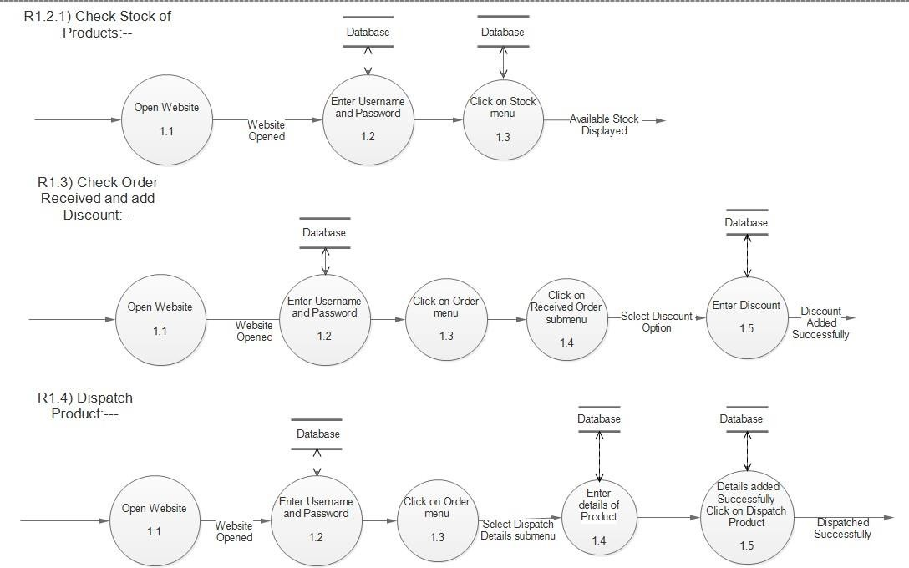

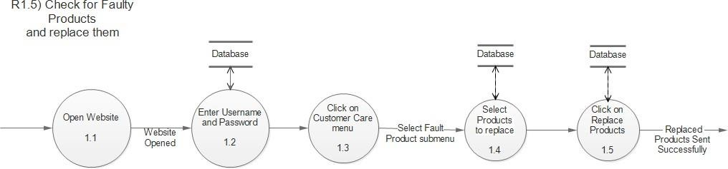

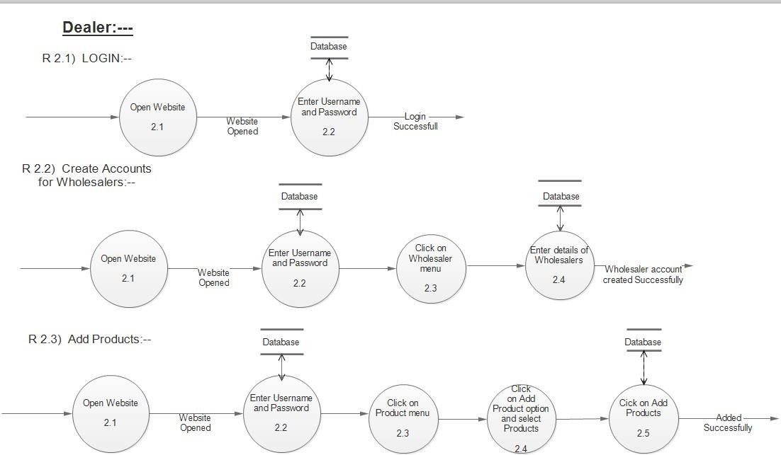

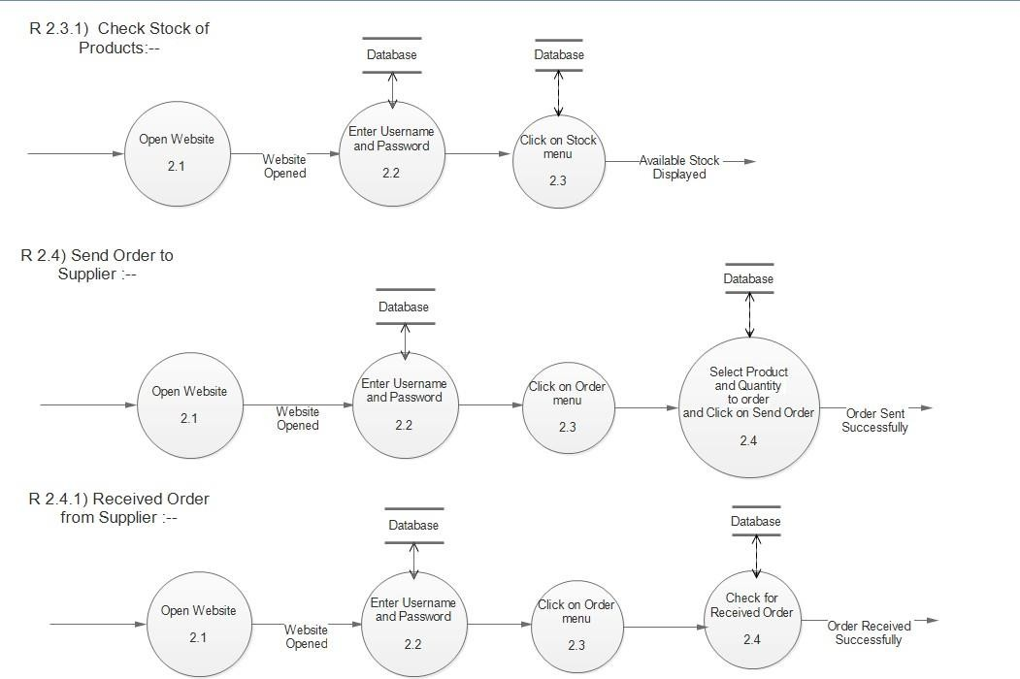

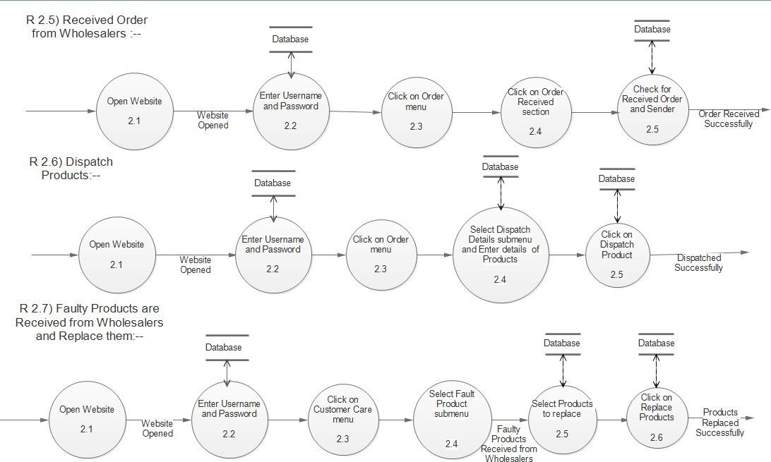

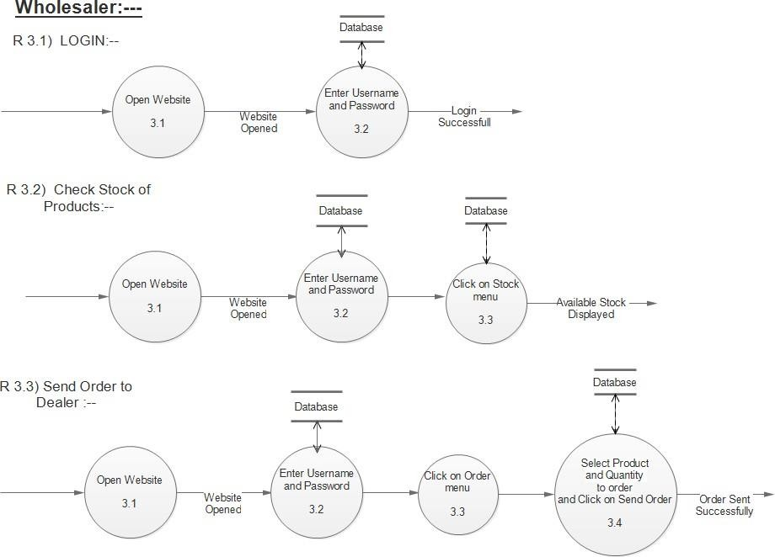

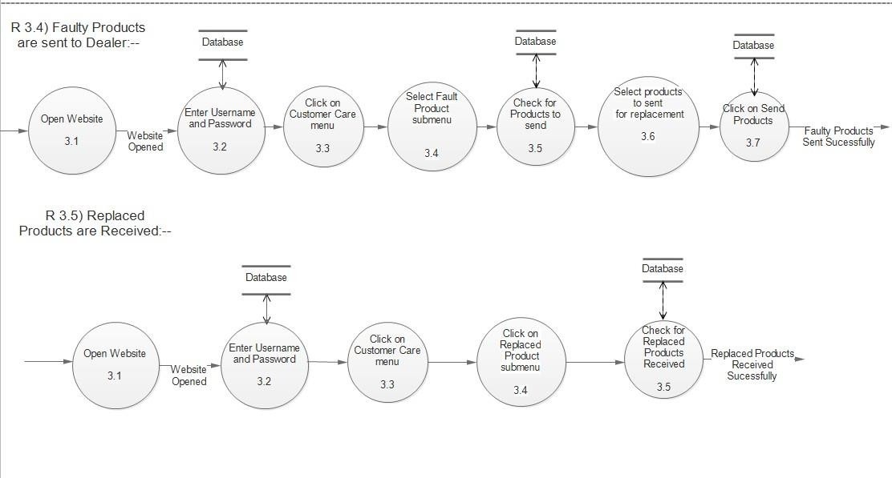

* + 1. **Process specification: -**
* PSPEC: Authentication
* This process is used for authentication. In this process, username and password is checked in database for authentication.
* PSPEC: Registration
* This process is performed by Supplier to register Dealer and wholesaler.
* PSPEC: Management
* This process provides the full access to Admin. Admin can manage the whole system.

##### Main Module

* Users Module: --- Users Module contains all the accounts. Admin will create the accounts for Supplier. And the Supplier will create the accounts for Dealers and Dealers will create the accounts for Wholesalers. Each account will have default passwords. All of them will be able to access the account by logging in that account.

##### Select of hardware and software and justification

HARDWARE SPECIFICATION: -

HARDWARE Requirement (Server Side): ➢

* Intel Core i3 8th Generation Processor
* RAM 2/4GB

HARDWARE Requirement (Client Side): ➢

* Intel core 2 duo Processor or higher, Smart mobile phone
* 2GB RAM or MORE
* 32/64 BIT SYSTEM ARCHITECTURE

SOFTWARE SPECIFICATION: -

SOFTWARE Requirement (Server Side): ➢

* Operating System: Windows 10
* HTML, CSS, JavaScript. PHP, XAMPP/WAMPP
* My SQL
* Browser: Mozilla Firefox, Google Chrome, Microsoft Edge

SOFTWARE Requirement (Client Side): ➢

* Operating System: Windows 7 or higher, Linux, Mac OS.
* Browser: Mozilla Firefox, Google Chrome, Microsoft Edge.

# CHAPTER*-*5



Database design/ Data structure design



Input /output and interface

##### Database Design/Data Structure Design

* + 1. **Tables and Relationship: -**



##### Input /output and interface

* + 1. Sample of forms, reports and interface: -
       - index.php: --

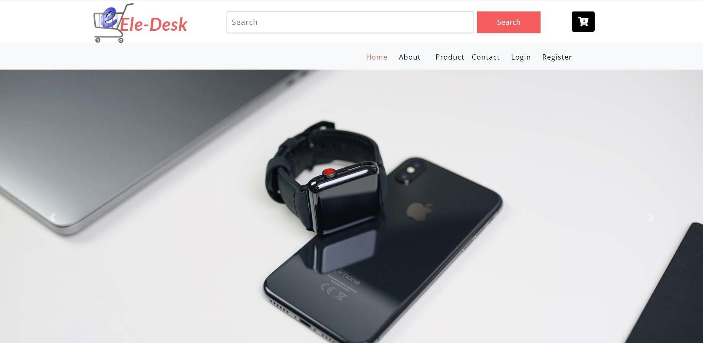

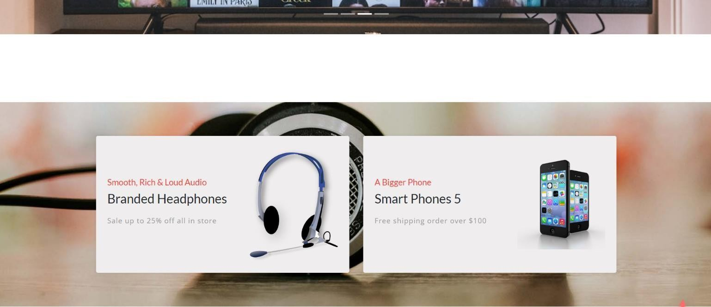

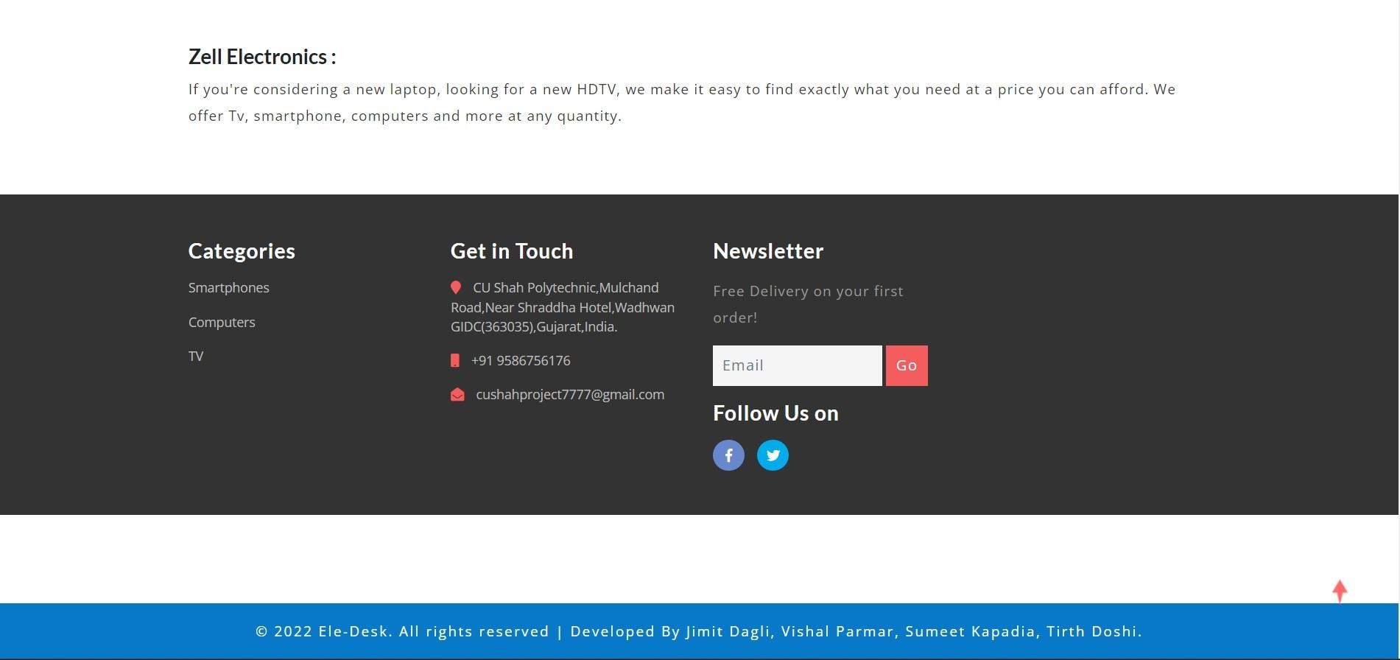

* + - * product.php: --

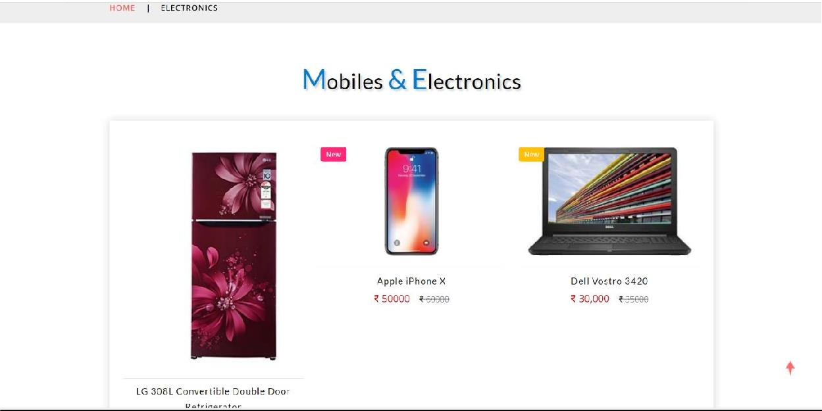

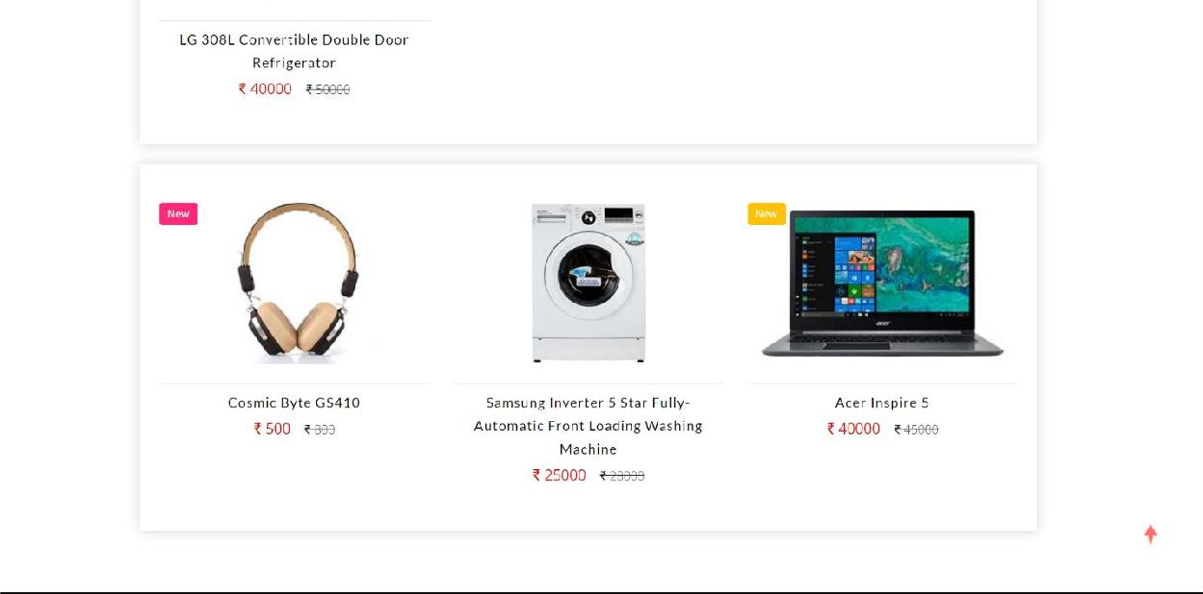

* + - * admin-area.php: --

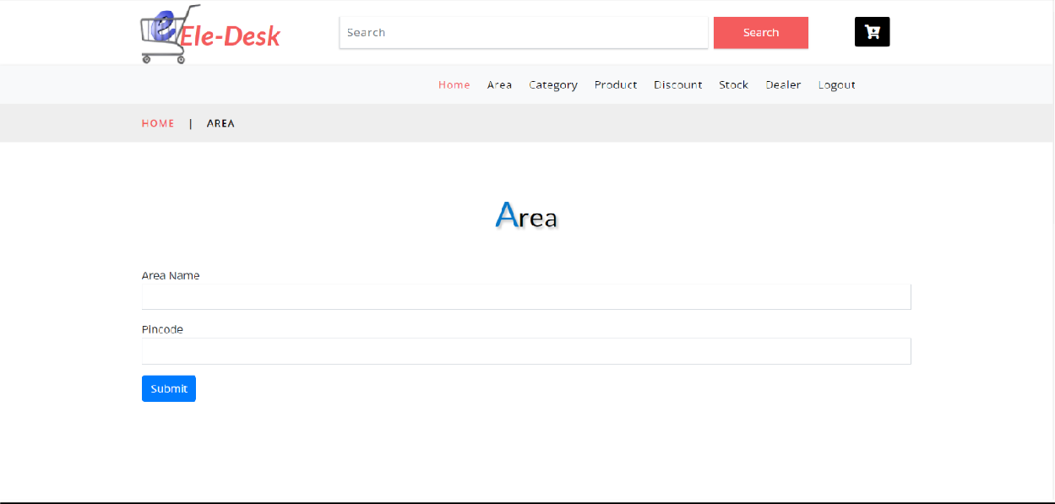

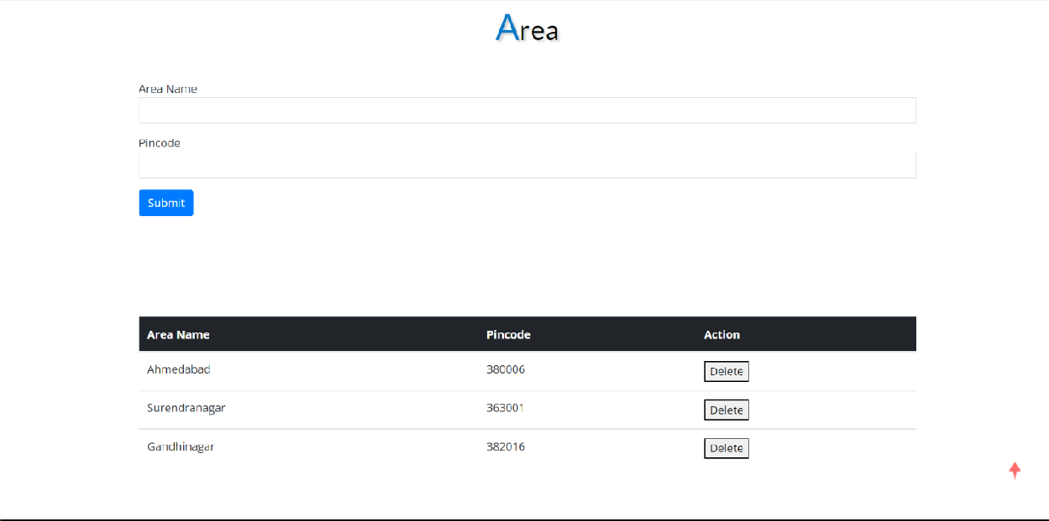

* + 1. Access control and security: -
       - Access Control: -- With Client side scripting and Validation control, the selective restriction of access to a place or resource—helps to protect against the most significant security threats. Access Control prohibits unauthorized access to create dealers account, create wholesalers account, add product stock, add discount to product etc.
       - Security: -- Security is provided by Admin. Data of Dealers and Wholesalers are secure under Admin.

# CHAPTER*-*6

* **6.1 .IMPLEMENTATION ENVIRONMENT**
* **6.2.PROGRAM/MODULE SPECIFICATION**
* **6.3.CODING STANDARD**
* **6.4.SAMPLE CODING**
  1. **IMPLEMENTATION ENVIRONMENT**
     + GUI / Non GUI:
* For a website, the GUI would typically be the graphical elements of the website that users interact with, such as buttons, menus, and forms. This includes both the front-end design of the website, as well as any back-end tools that are used to manage the website.
  + - Implementation Planning
* Implementation phase requires precise planning and monitoring mechanism in order to ensure schedule and completeness.
* We developed the software in various sub phases in implementation phase.
* These steps are as follows:
  + Defining project scope: This involves identifying the goals of the website, the target audience, and the features and functionality that are required.
  + Developing a project plan: This involves creating a detailed project plan that outlines the timeline for the implementation, key milestones, and the tasks that need to be completed.
  + Allocating resources: This involves identifying the personnel, technology, and budget required to develop and launch the website. It also involves ensuring that the necessary resources are available throughout the implementation process.
  + Selecting technology and platforms: This involves selecting the technology and platforms that will be used to build the website, such as content management systems, web development frameworks, and hosting providers.
  + Designing the website: This involves creating the visual design of the website, including the layout, typography, and color scheme.
  + Testing and quality assurance: This involves testing the website to ensure that it works properly and meets the requirements outlined in the project plan.
  + Deployment and launch: This involves deploying the website to the hosting provider and launching it to the public.

###### PROGRAM/MODULE SPECIFICATION

* + - Common Specifications:-
* Validation for Numeric, Alphabetic & Special cases like Email etc. are used.
* Redirection and confirmation for each registration is maintained properly.
* Necessity of fields is checked properly.
* Role management is done appropriately according to login.
* Each user has specific pages to be shown according his role.
  + - Specifications of Modules:-
* As the discussion of modules it starts basically from home page of the site.
* From home page the total site is divides into some panel view.
* Each panel is specifically made for the direct use of some functionality according to user role.
* View the related information according to their person type or Role of them.
* Basically the total system till now developed is divided in Three main modules based on working of the system and flow of the system :
* Admin:-
  + In this module, the admin will create account for dealer.
  + Admin can view stock of product.
  + Admin can give discount on category of product.
  + Admin can receive order form dealer.
  + Admin can outward dealer’s order.
* Dealer:-
  + In this module, the dealer will create account for wholesaler.
  + Dealer can view its stock of product.
  + Dealer can give discount on category of product.
  + Dealer can receive order form wholesaler.
  + Dealer can outward wholesaler’s order
  + Dealer can place order to admin.
* Wholesaler:-
  + Wholesaler can view its stock of product.
  + Wholesaler can place order to dealer.

###### CODING STANDARD

* + - Variable Standards
* Variable name can contain letters, digits and underscore symbol.
* It can’t start with digits.
* You can’t use white space in the name of the variable.
* Uppercase and lowercase letters are distinct.

###### SAMPLE CODING

* + - dealer-send-order.php

# <?php include("vheader.php");?>

# <?php include("dealermenu.php");?>

# <?php?>

# include("connection.php");

# <!-- banner-2 -->

# <!-- //banner-2 -->

# <!-- page -->

# <div class="services-breadcrumb">

# <div class="agile_inner_breadcrumb">

# <div class="container">

# <ul class="w3_short">

# <li>Send Order</li>

# <li>

# </li>

# <a href="index.html">Home</a>

# <i>|</i>

# <script src="https://unpkg.com/@lottiefiles/lottie- player@latest/dist/lottie-player.js"></script>

# <lottie-player src="https://assets7.lottiefiles.com/packages/lf20_pMgZwk.json" background="transparent" speed="1" style="width: 1100px; height: 300px;" loop autoplay></lottie-player>

# </div></div>

# </div>

# </ul>

# <!-- //page -->

# <!-- form part -->

# <div class="contact py-sm-5 py-4">

# <div class="container py-xl-4 py-lg-2">

# <!-- tittle heading -->

# <h3 class="tittle-w3l text-center mb-lg-5 mb-sm-4 mb-3">

# <span>S</span>end-Order

# </h3>

# <div class="contact py-sm-5 py-4">

# <div class="container py-xl-4 py-lg-2">

# <!-- form -->

# <form action="dealer-order-send-code.php" method="post">

# <form>

# <div class="mb-3">

# <label>Order date</label>

# <input type="text" readonly value="<?php print date('d-m-Y') ?>" class="form-control" name="date">

# </div>

# <div class="dropdown">

# <label for="exampleInputDropdown1"

# class="form-label">Product</label>

# <?php

# <select name="product_id" class="form-control">

# $qstock = "select * from product";

# $rsstock= mysqli_query($con,$qstock); mysqli_fetch_array($rsstock)){

# value=$rowstock[0]> $rowstock[1] </option>";

# while($rowstock =

# echo "<option

# }

# ?>

# </select>

# </div>

# name="quantity">

# <br>

# <div class="mb-3">

# <label>Quantity</label>

# <input type="number" class="form-control"

# <br>

# </div>

# <div class="mb-3">

# <label>Remarks</label>

# <input type="textarea" col="50"

# row="5"class="form-control" name="remarks">

# </div>

# <”primary">Submit</button>

# <br>

# <button type="submit" class="btn btn-

# </form>

# </form>

# </div>

# </div>

# </div>

# <!-- //form -->

# <!-- //form part -->

# <?php include("footer.php");?>

# dealer-send-order-code.php<?php

# session_start();

# include("connection.php");

# $order_date=date('Y-m-d');

# $user_id = $_SESSION['user_id'];

# $product_id=$_POST["product_id"];

# $quantity=$_POST["quantity"];

# $remarks=$_POST["remarks"];

# $payment_status="N";

# $query = "insert into order_master(order_date,product_id,user_id,quantity,payment_status,remarks)

# values('$order_date','$product_id','$user_id','$quantity','$payment_status','$remarks ')";

# mysqli_query($con,$query);

# print $query;

# header("Location:dealer-my-orders.php");

# CHAPTER*-*7

* + - **7.1. TESTING PLANS**
    - **7.2. TESTNG STATERGY**
    - **7.3.TESTING METHODS**
    - **7.4. TEST CASES**
  1. **TESTING PLAN**
     + A test plan documents the strategy that will be used to verify and ensure that a product or system meets its design and its specifications and other requirements. A test plan is usually prepared by or with significant input from Test Engineers.
     + Depending on the product and responsibility of the organization to which the test plan applies, a test plan may include one or more of the following: -
     + Design verifications and compliance test: -
     + To be performed during the development or approval stages of the product, typically an on a small sample of units.
     + Manufacturing or production test: -
     + To be performed during preparation or assembly of the product in an ongoing manner for purpose of performance verification and quality control.
     + Acceptance or commissioning test: -
     + To be performed at the time of delivery or installation of the product.
     + Service and Repair test: -
     + To be performed as required over the service life of the product.
     + Regression test: -
     + To be performed on an existing operational product, to verify that existing functionality didn’t get broken where other aspect of the environment are changed.(e.g. upgrading the platform on which an existing application runs.)
     + **TESTING PROCESS**
     + I have tested the software process activities such as design, implementation and requirement engineering because design error is very costly to repair once system has been start started to operate. Therefore, it is quite obvious to repair them at early stage of the system. So, analysis is the most important process in any project.
     + As the most important portion is whether the system is meeting its requirements or not, for that testing should be planned so that all requirements are individually tested. I have to

Check out the output of certain combination of inputs gives the desirable results or not. Your requirement specifications give us the path to get desirable results.

* + - In this project, the tested items are like: -
    - Accessing of specific data for specific users.
    - Validation using php.
    - Authenticate of specific users.
    - Ensuring if enough stock is not available at the time of outward error MSG will be displayed.
    - Ensuring that users can send and receive order.

###### TESTING STATERGY

* + - System testing is an expensive but critical process that can take as much as 50% of the budget of the program development. So testing is most important part of the system. The common view of testing held by users is that it is performed to prove that there are no errors in the program but the powerful approach is the explicit intention of finding error. e.g making the program fail. Thus, the system that is developed is exhaustively tested before it is finally implemented and comes on line.

1. Code Testing: -
   * Code testing is done to examine the logic of the problem.
   * Analyst test every path through the program.
   * A path is specific combination of condition that is handled by the program.
   * Code testing seems to be a method for testing software.
   * In this project the expert programmer tests the code.
2. System Testing: -
   * Entire system is tested as per the requirement.
   * Black-box type testing that is based on overall requirements specifications, covers all combined parts of the system.
3. Storage Testing: -
   * I specify a capacity for the system when it is designed and constructed.
   * Capacities are measured in terms of the number of records that a disk will handle or file can contain.
4. Alpha Testing: -
   * The above testing process described takes place in different stages of development as per the requirements and needs.
   * But a final testing is always made after a full finished product that is before it released to end users and this is called as alpha testing.
   * The alpha testing involves both the white-box testing and black-box testing thus making the alpha testing carried out in two phases.
5. Beta Testing: -
   * This process of testing is carried out to have more validity of the software developed.
   * This takes place after the alpha testing.
   * After the alpha phase also generally, the release is not made fully to end users.
   * The server is released to a set of people and feedback is got from them to ensure the validity of the server.
   * So here normally testing is being done by group of end users and therefore this beta testing phase covers black box testing or functionality testing only.

###### TESTING METHODS

* + - Software testing methods are traditionally divided into black box testing and white box testing. These two approaches are used to describe the point of view that a test engineer takes when designing test cases.
* Black Box Testing: -
  + - It takes an external perspective of the object to derive test cases. These tests can be functional or non-functional, through usually functional. The test designer selects valid and invalid input and determines the correct output.
    - There is no knowledge of the test object’s internal structure. Black Box Testing is testing without knowledge of the internal working of the item being tested.
    - For example, when black box testing is applied to software engineering, the tester would only know the ‘legal’ inputs and what the expected outputs should be, but not how the programs actually arrives at those outputs. It is because of this that black box testing can be considered testing with respect to the specifications, no other knowledge of the program is necessary.
    - For this reason, tester and programmer can be independent of one another, avoiding programmer bias towards his own work.
    - Due to nature of black box testing, the test planning can begin as soon as specifications are written.
* White Box Testing: -
  + - The opposite of black box testing would be glass box testing, where the data are derived from the direct examination of the code to be tested.
    - For glass box testing, the test cases cannot be determined until the code has actually been written.
    - Both of these testing techniques have advantages and disadvantages, but when combined they help to ensure through testing of the product.
    - Software testing approaches that examine the program structure and derive test data from the program logic. Structural testing is sometimes referred to as a clear box testing since white boxes are considered opaque and do not really permits visibility into the code.
* Unit Testing: -
  + - Unit testing is the process of test verification on the smallest unit of the software design- software module.
    - It is used to uncover errors within the boundary of the module.
* Integrating Testing: -
  + - Integration testing is associating with unit testing.
    - Here the modules of unit testing are put together and checked weather they work properly, when they are integrated or not. It contains different strategies for same. They are as follows.
    - I performed integrating testing by merging all the Modules and Testing as whole Application. I used one Test Case for Flow of whole Application and remove the Errors.
    - Validation Testing:-

|  |  |  |  |  |  |
| --- | --- | --- | --- | --- | --- |
| **Sr no:** | **Test case** | **Input** | **Expected**  **O/P** | **Actual**  **O/P** | **Result** |
| **1** | Press submit button without entering email | Email field empty | Error “email field cannot be empty” | Error “email field cannot be empty” | Pass |

* + - In integration testing, the software is assembled as a package.
    - Validation Testing is Completely associated with requirement satisfaction of customers.
    - This testing checks weather all functional requirements of customer are satisfied or not.
    - According to this test, the project is tested and found to be satisfactory for functional characteristics, behavioral characteristics and performance requirement.

###### TEST CASES

* + - A Test Case describes exactly how the test should be carried out.
    - The system test cases help us to verify and validate the system.
    - The system Test Cases are written such that:
    - They cover all the use cases and scenarios.
    - The Test cases validate the technical Requirements and specifications.
    - The Test cases verify if the application/System meet the Business & Functional.
    - The Test cases may also verify if the system meets the performance standards Since a dedicated test team may execute the test cases it is necessary that System Test Cases.
    - The detailed Test cases help the test executioners do the testing as specified without any ambiguity.
* **Login test case:**

|  |  |  |  |  |  |
| --- | --- | --- | --- | --- | --- |
| **Sr no:** | **Test case** | **Input** | **Expected**  **O/P** | **Actual**  **O/P** | **Result** |
| 1 | Press submit button without entering email | Email field empty | Error “email field cannot be empty” | Error “email field cannot be empty” | Pass |
| 2 | Press submit button without entering  password | Password field empty | Error “password field cannot be empty” | Error “password field cannot be empty” | Pass |
| 3 | Press submit button with entering  wrong email | Wrong Email | Error “email is wrong” | Error “email is wrong ” | Pass |
| 4 | Press submit button with entering wrong  password | Wrong password | Error “password is wrong” | Error “password is wrong ” | Pass |

# CHAPTER*-*8

###### ADMIN SIDE SCREENSHOTS

* **Dealer SIDE SCREENSHOTS**
* **Wholesaler SIDE SCREENSHOTS**

1. **Home Page**

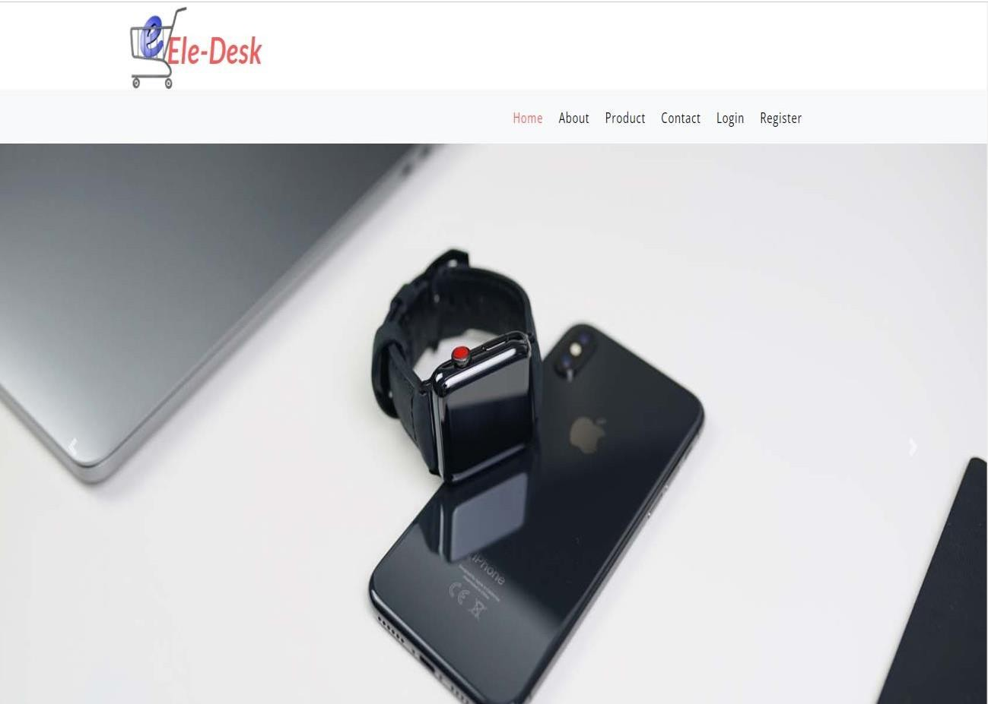

1. **Login page.**

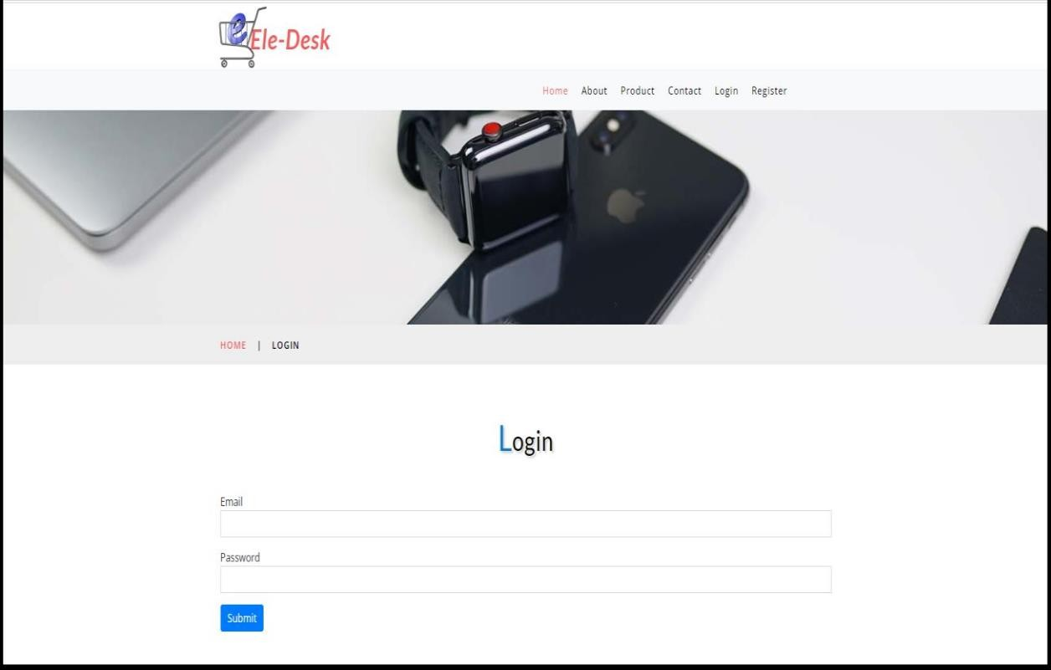

1. **Admin’s order page**

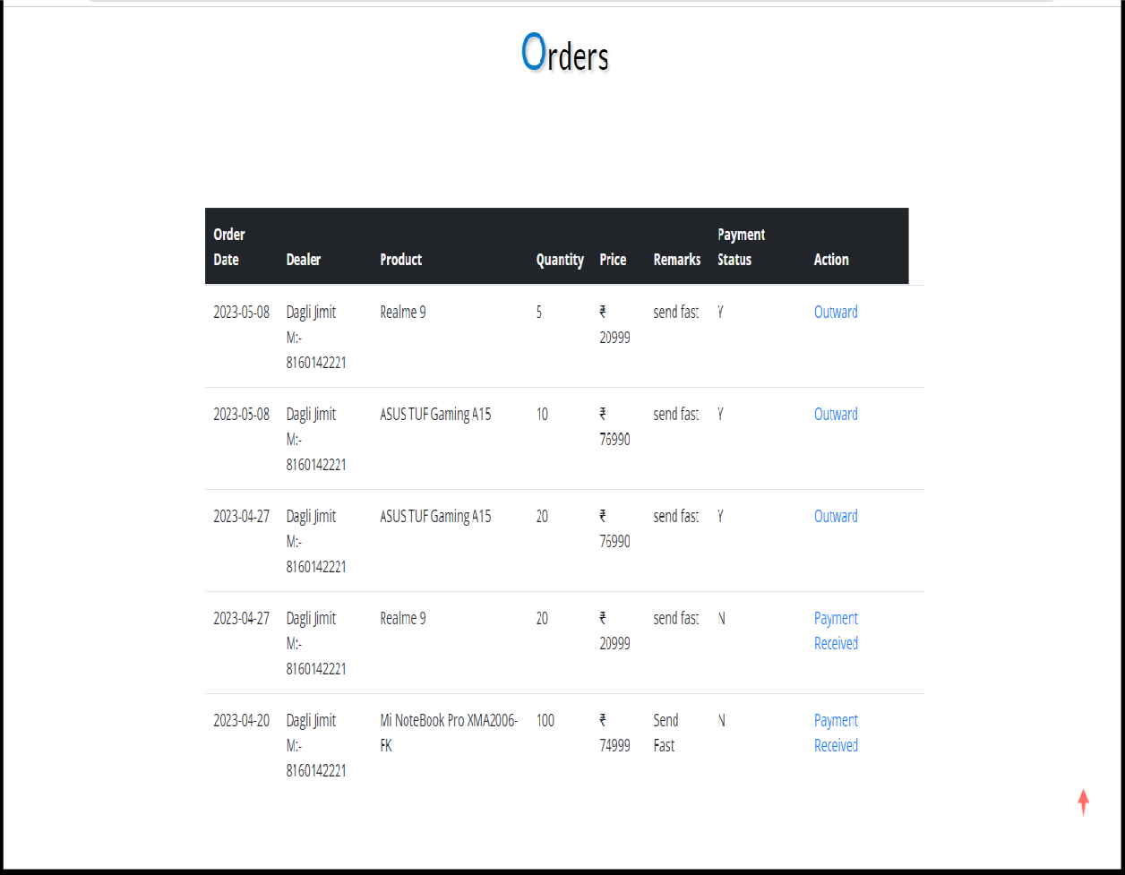

1. **Admin’s outward view Page**

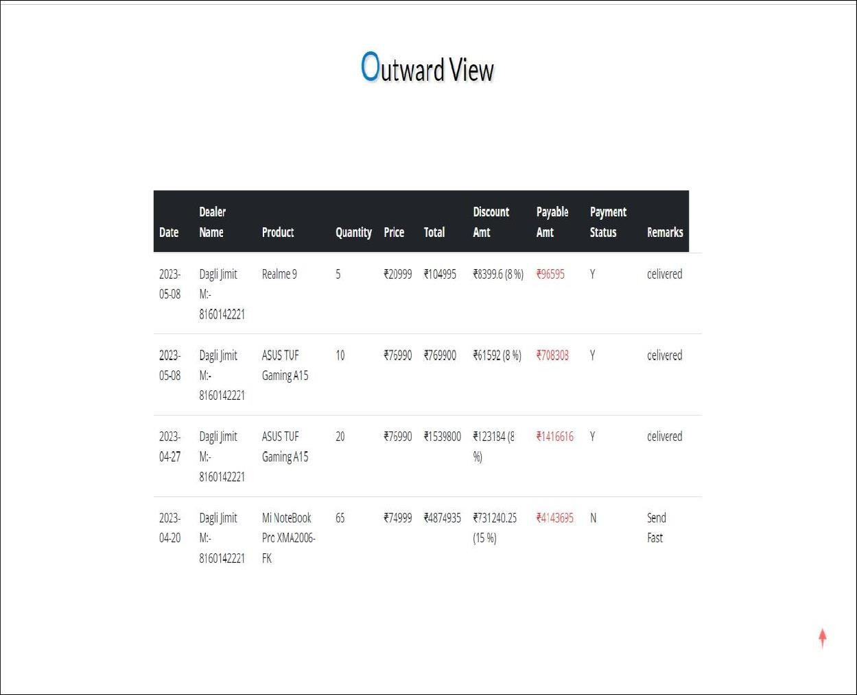

1. **Admin-create dealer**

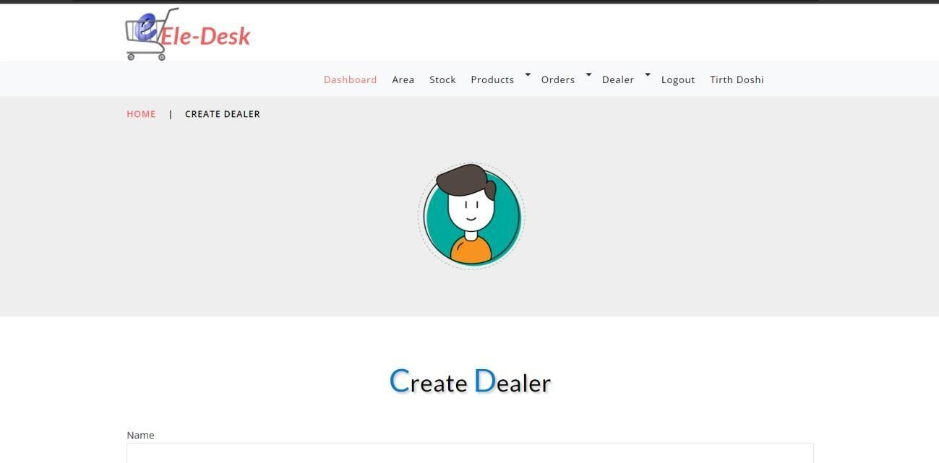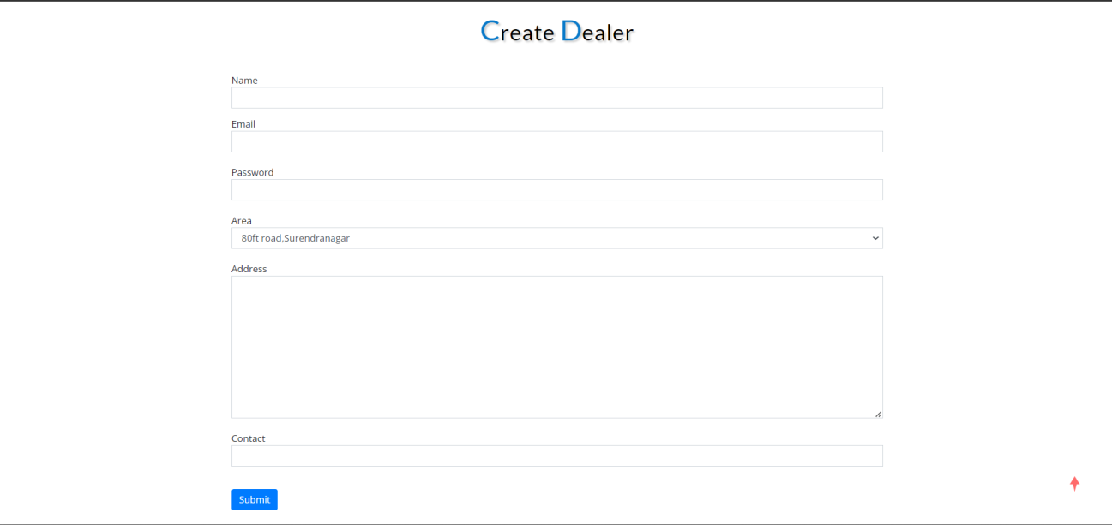

1. **Dealer’s My order page**
   * In This page all the order that dealer has placed to admin will be displayed.

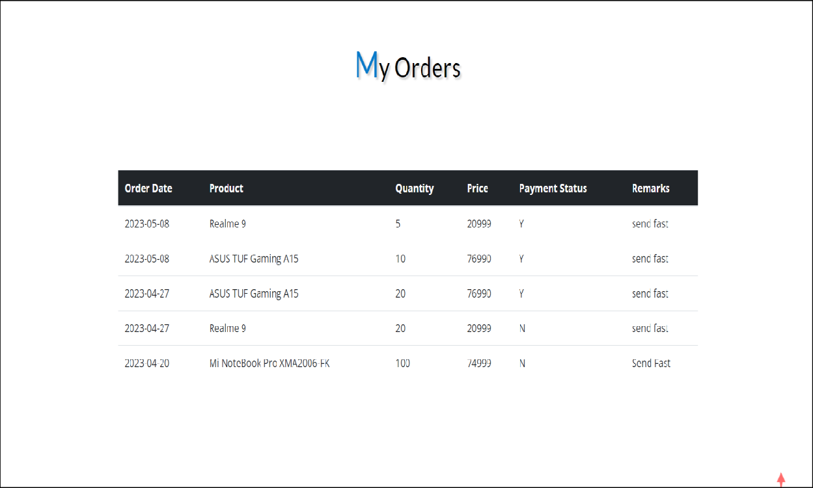

1. Dealer’s inward view page
   * In This page outward of admin will be displayed as inward view.

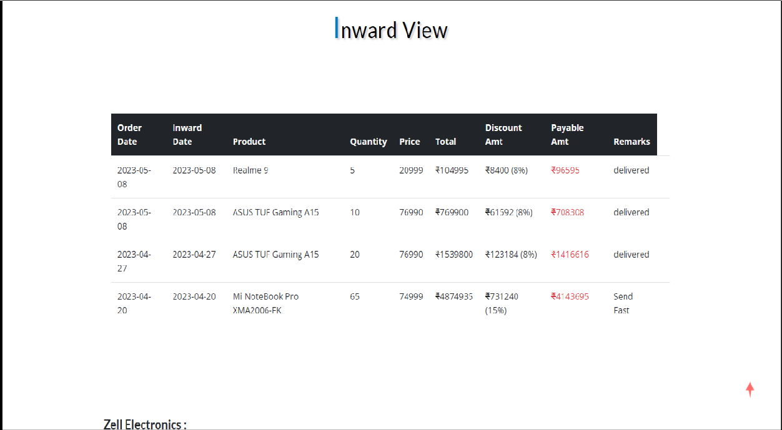

1. Dealer-create wholesaler acc.
   * In this page dealer will create account for wholesaler.

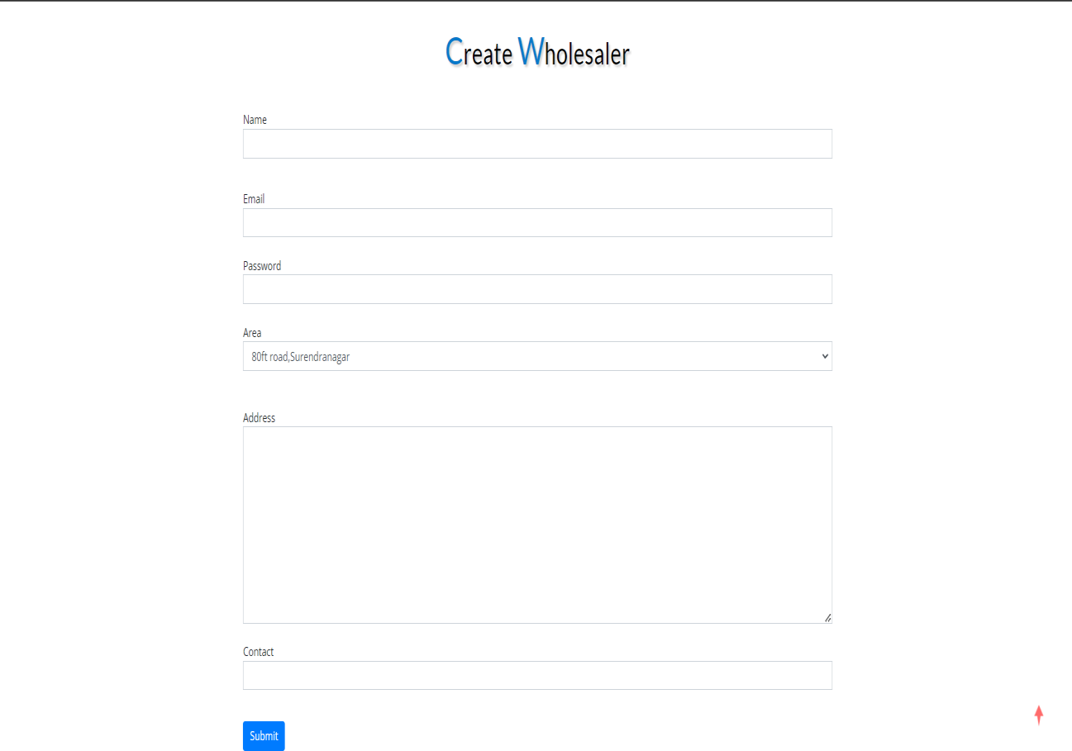

1. Wholesaler send order page
   * In this page wholesaler can place order to dealer.

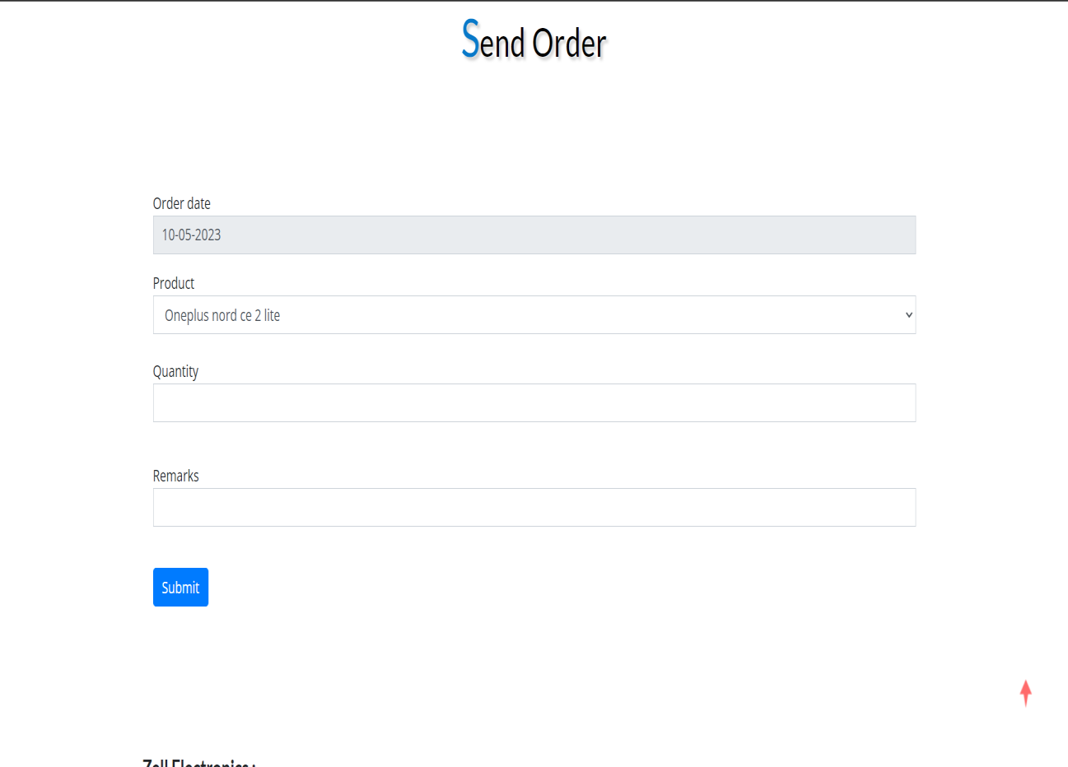

1. Wholesaler stock
   * In this page wholesaler can view available stock.

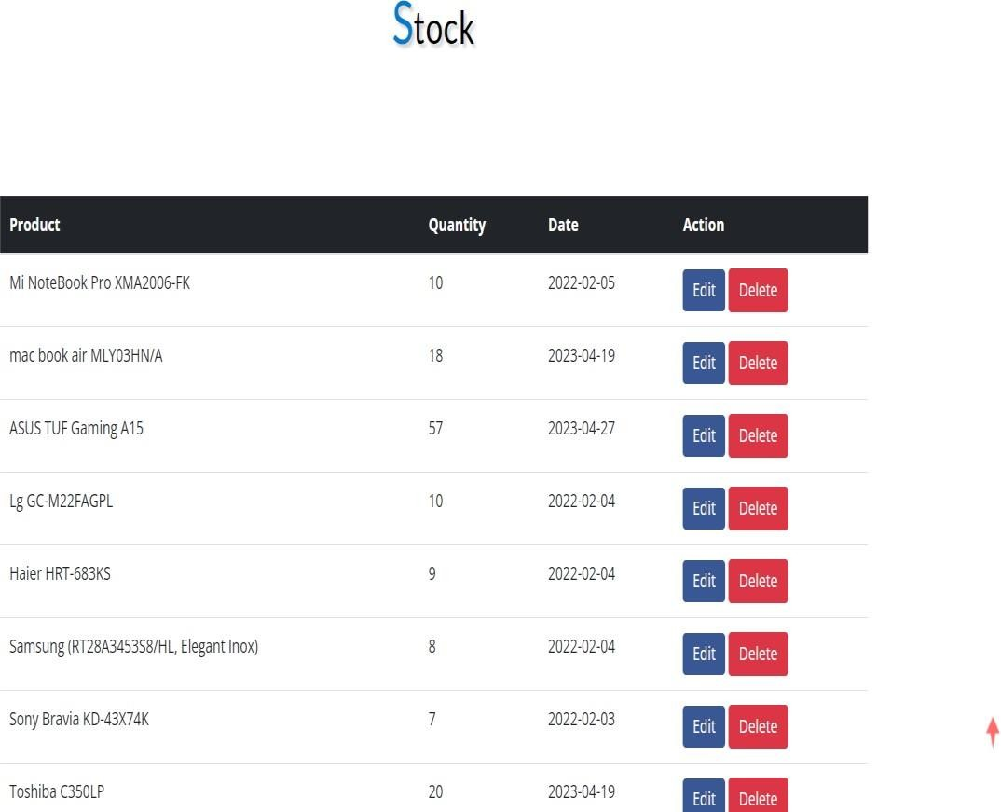

# CHAPTER*-*9

* **LIMITATIONS**
* **FUTURE ENHANCEMENT**
* **LIMITATIONS**
  + Online payment system is absent in our website.
  + Faulty product are not managed.
  + This website is not for end users.
* **FUTURE ENHANCEMENT**
* Right now, we are only launching the website but In future we planning to add online payment system.
* Right now, we are only launching the website but In future we planning to add new exchange system for faulty product.

**CHAPTER*-*10**

* **CONCLUSION**
* **REFRENCE**

#### Conclusion:

* Ele-Desk project served as a great learning experience for us. It gave us the opportunity to work as a team. Through this experience, we have learned to do all task as a team but we have also learned to be more responsible.
* We are motivated through Amazon because it connects Customer with Dealer. There’s only few websites that manages order’s flow between Manufacturer (Admin) to Dealer and Dealer to Wholesaler and we are one of them.
* In conclusion, a website for Ele-Desk can greatly enhance the efficiency and effectiveness of business operations. By providing a platform for communication and collaboration, as well as real-time data analysis and monitoring, an Ele-Desk website can help organizations improve their work flow visibility, reduce costs, and increase customer satisfaction.
* Through the website, organizations can automate processes, such as task management and optimize work levels.
* “Ele-Desk” is for resolving the problem of offline purchases and with this, we can make online order which helps in saving time and money that is spent on traveling to supplier.
* Overall, a website for Ele-Desk can provide significant benefits to organizations by improving their work flow visibility, reducing costs, and increasing efficiency and customer satisfaction. It's important to ensure that the website is user-friendly, secure, and accessible to all relevant users.

#### Reference

* Amazon website: <https://WWW.amazon.com>
* Delhivery website: <https://WWW.delhivery.com>